**IRON CONTENT**

**MANAGEMENT**

* **Dharni S S (2016103022)**
* **Naveen Kumar (2016103038)**

**ER diagram :**

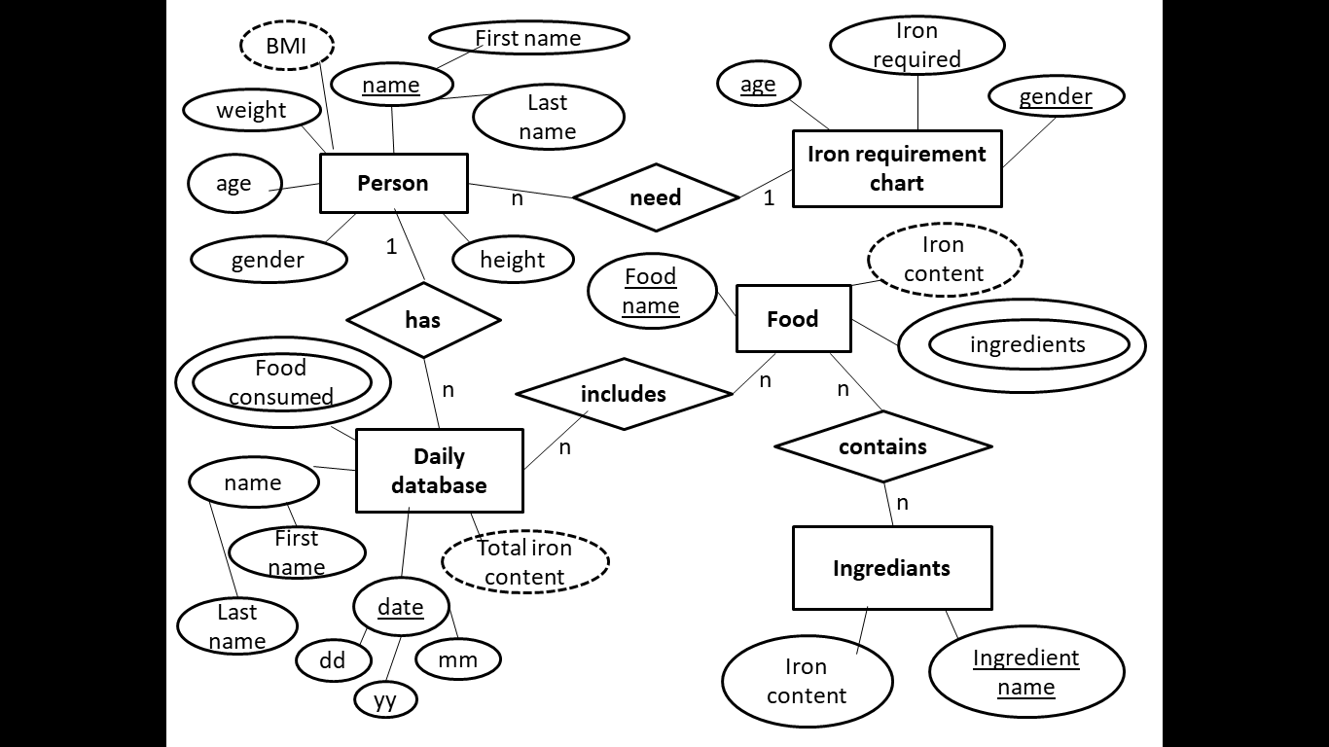

Relational schema :

